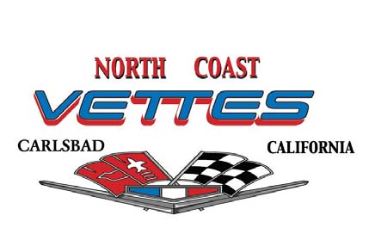
2025 North Coast Vettes Membership Application/Renewal

Member Name_________________________________________________

Member Name _______________________________________________

Birth Date_____________________________ Birth Date____________________________
Month/Day Month/Day

Street Address _________________________City__________________ State_____ Zip____________

Home Phone: ( ) ____________________________ Work Phone ( ) ________________________

Cell Phone 1: ( )_____________________________ Cell Phone 2: ____________________________

E-mail: 1 _____________________________________ E-mail: 2 _______________________________

CORVETTE Information

Year: __________ Model: _________________ Color: ________________ License: ________________

Year: __________ Model: _________________ Color: ________________ License: ________________

Year: __________ Model: _________________ Color: ________________ License: ________________

Annual Dues: Individual Member $36.00 and Couples $72.00
Please Print, Sign and Date and Include Along with the Liability Waiver Form

Signature Active Member Date Signature Active Member Date
 | ___
_________________________ ___________ | ___________________________ ___________

New members must attend two monthly car club meetings as a guest prior to joining.
Renewal Deadline is no-later-than the February meeting of each year. For renewal, please bring your check and this form to the January car club meeting or mail it to:
Scott McClellan
2148 View Crest Glen
Escondido, CA 92026

www.northcoastvettes.org

